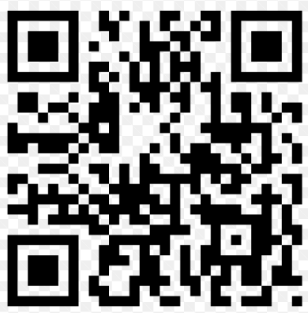
APP at Apple APP Store | APP at Google Play Store | Download Android APP directly

“DaLaBa” Mobile APP
- Discover what people nearby are saying;
- Broadcast your ideas to people nearby;
- This is a localized Twitter;

